CSCE 310: Database Systems HW 2

Raymond Zhu

923009555

1.

{ acctNo = ‘12345’ | type = ‘savings’, balance = 12000; }

{ acctNo = ‘23456’ | type = ‘checking’, balance = 1000; }

{ acctNo = ‘34567’ | type = ‘savings’, balance = 25; }

2.

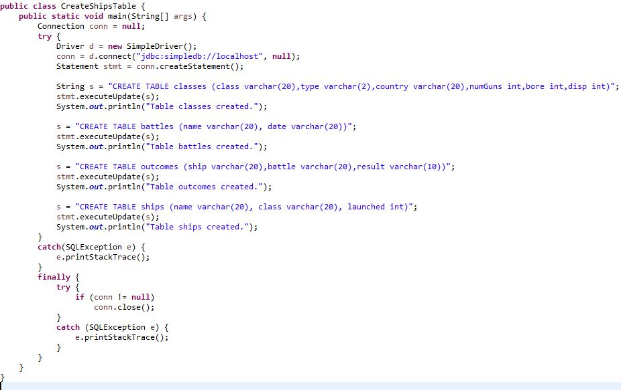

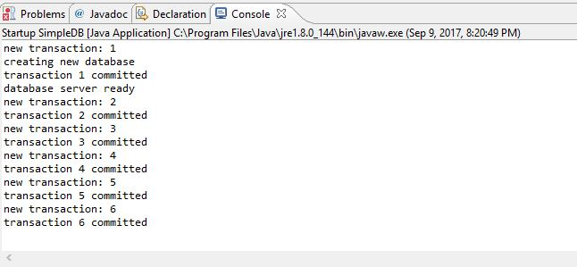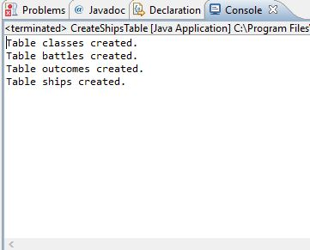

3.

**select SId, Sname from student;**

* The command is selecting the id and name of every student in the student table. The students are ordered by SId in the projection.

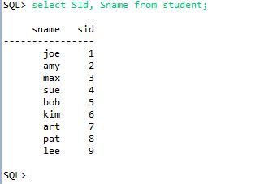

**select EId from section, enroll;**

* The enroll table is scanned in the inner loop. For every section, the command will grab every enrollment id in the enroll table.

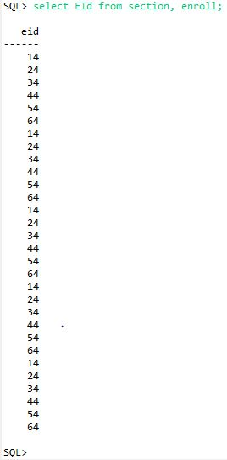

**Select EId from enroll, section**

* Since the section table is in the inner loop, for each enrollment id, the command will return the same enrollment id x number times – where x is the number of sections in the section table.

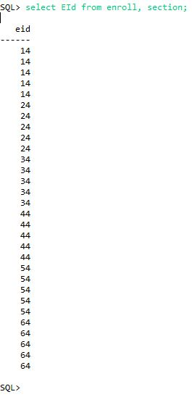

**select Title, SectId from course, section where CId=CourseId and Prof='turing';**

* Since both tables share a relation given the course id, the command returns the title and section id for every course id that has professor turing.

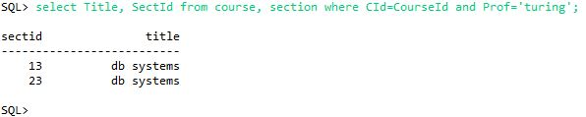

**select SName,GradYear from student, dept where MajorId = DId and DId=20;**

* The command is selecting the student name and graduation year attribute from the student table where each student ‘s department id is equal to 20. A relation is shared between MajorId and DId for both tables. 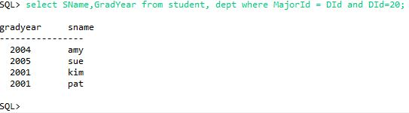

**select SName,GradYear from student, dept where MajorId = 20;**

* Not the same as the previous. The command is selecting the SName and GradYear of each student in the student table where the student’s MajorId is equal to 20. Since dept is nested in the inquiry, and no relation is specified between the two tables, each student is repeated by the number of departments in the dept table.

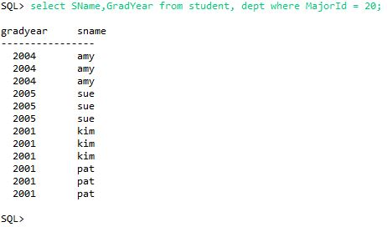

4a.

$π_{class, country}\left(σ_{bore≥16}\left(Classes\right)\right)$

|  |  |
| --- | --- |
| **Class** | **Country** |
| IOWA | USA |
| NORTH CAROLINA | USA |
| YAMATO | JAPAN |

4b.

$$π_{name}\left(σ_{launched <1921}\left(Ships\right)\right)$$

|  |
| --- |
| **Name** |
| Haruna |
| Hiei |
| Kirishima |
| Kongo |
| Ramillies |
| Renown |
| Repulse |
| Resolution |
| Revenge |
| Royal Oak |
| Royal Sovereign |
| Tennessee |

4c.

$$π_{ship}\left(σ_{battle=^{'}Denmark Strait^{'}} AND σ_{result=^{'}sunk^{'}}\left(Outcomes\right)\right)$$

|  |
| --- |
| **Ship** |
| Bismarck |
| Hood |

$$π_{ship}$$

$$∩$$

$σ_{battle=^{'}Denmark Strait^{'}}$ $σ_{result=^{'}sunk^{'}}$

$Outcomes$ $Outcomes$

4e.

S = Ships & C = Classes

$$π_{S.name,C.displacement,C.numGuns}\left(σ_{S.class=C.class}\left(S ⋈ C\right)∩σ_{battle=^{'}Guadalcanal^{'}}(Outcomes)\right)$$

|  |  |  |
| --- | --- | --- |
| **Name** | **Displacement** | **Number of Guns** |
| Kirishima | 32000 | 8 |
| Washington | 37000 | 9 |

$$π_{Ships.name, Classes.displacement,Classes.numGuns}$$

$$∩$$

$σ_{Ships.class=Classes.class}$ $σ_{battle=^{'}{Guadalcanal}^{'}}$

$Ships⋈Classes$ $Outcomes$

5a.

$$π_{class}\left(Classes\right)⊆π_{class}\left(σ_{bore≤16}\left(Classes\right)\right)$$

5b.

$$π_{class}\left(σ_{numGuns>9}\left(Classes\right)\right)⊆π_{class}\left(σ_{bore≤14}\left(Classes\right)\right)$$

6.

C:\Apache\db-derby-10.13.1.1-bin\bin>java -version

java version "1.8.0_144"

Java(TM) SE Runtime Environment (build 1.8.0_144-b01)

Java HotSpot(TM) 64-Bit Server VM (build 25.144-b01, mixed mode)

7.

C:\Apache\db-derby-10.13.1.1-bin\bin>java org.apache.derby.tools.sysinfo

------------------ Java Information ------------------

Java Version: 1.8.0_144

Java Vendor: Oracle Corporation

Java home: C:\Program Files\Java\jre1.8.0_144

Java classpath: C:\Apache\DB-DER~1.1-B\lib\derby.jar;C:\Apache\DB-DER~1.1-B\lib\derbytools.jar;C:\Apache\DB-DER~1.1-B/lib/derbyoptionaltools.jar;C:\Apache\db-derby-10.13.1.1-bin\lib\derby.jar;C:\Apache\db-derby-10.13.1.1-bin\lib\derbytools.jar;.

OS name: Windows 10

OS architecture: amd64

OS version: 10.0

Java user name: rayzr

Java user home: C:\Users\rayzr

Java user dir: C:\Apache\db-derby-10.13.1.1-bin\bin

java.specification.name: Java Platform API Specification

java.specification.version: 1.8

java.runtime.version: 1.8.0_144-b01

--------- Derby Information --------

[C:\Apache\db-derby-10.13.1.1-bin\lib\derby.jar] 10.13.1.1 - (1765088)

[C:\Apache\db-derby-10.13.1.1-bin\lib\derbytools.jar] 10.13.1.1 - (1765088)

[C:\Apache\db-derby-10.13.1.1-bin\lib\derbyoptionaltools.jar] 10.13.1.1 - (1765088)

------------------------------------------------------

----------------- Locale Information -----------------

Current Locale : [English/United States [en_US]]

Found support for locale: [cs]

version: 10.13.1.1 - (1765088)

Found support for locale: [de_DE]

version: 10.13.1.1 - (1765088)

Found support for locale: [es]

version: 10.13.1.1 - (1765088)

8.

ij> connect 'jdbc:derby:manfDB2;create=true';

ij> CREATE TABLE product (

maker char(1),

model char(4),

type varchar(8)

> > > > );

0 rows inserted/updated/deleted

ij> CREATE TABLE pc (

model char(4),

speed float,

ram int,

hd int,

> > > > > price decimal(4,0)

);

> 0 rows inserted/updated/deleted

ij> CREATE TABLE laptop (

model char(4),

speed real,

ram int,

hd int,

screen decimal(3,1),

price decimal(4,0)

);

CREATE TABLE printer (

model char(4),

color varchar(5),

type varchar(8),

price decimal(4,0)

> > > > > > > 0 rows inserted/updated/deleted

ij> > > > > > );

0 rows inserted/updated/deleted

ij> INSERT INTO printer VALUES ('3001','true','ink-jet',99);

INSERT INTO printer VALUES ('3002','false','laser',239);

INSERT INTO printer VALUES ('3003','true','laser',899);

INSERT INTO printer VALUES ('3004','true','ink-jet',120);

INSERT INTO printer VALUES ('3005','false','laser',120);

INSERT INTO printer VALUES ('3006','true','ink-jet',100);

INSERT INTO printer VALUES ('3007','true','laser',200);

INSERT INTO laptop VALUES ('2001',2.00,2048,240,20.1,3673);

INSERT INTO laptop VALUES ('2002',1.73,1024,80,17.0,949);

INSERT INTO laptop VALUES ('2003',1.80,512,60,15.4,549);

INSERT INTO laptop VALUES ('2004',2.00,512,60,13.3,1150);

INSERT INTO laptop VALUES ('2005',2.16,1024,120,17.0,2500);

INSERT INTO laptop VALUES ('2006',2.00,2018,60,15.4,1700);

INSERT INTO laptop VALUES ('2007',1.83,1024,120,13.3,1429);

INSERT INTO laptop VALUES ('2008',1.60,1024,100,15.4,900);

INSERT INTO laptop VALUES ('2009',1.60,512,80,14.1,680);

INSERT INTO laptop VALUES ('2010',2.00,2048,160,15.4,2300);

INSERT INTO pc VALUES ('1001',2.66,1024,250,2114);

INSERT INTO pc VALUES ('1002',2.10,512,250,995);

INSERT INTO pc VALUES ('1003',1.42,512,80,478);

INSERT INTO pc VALUES ('1004',2.80,1024,250,649);

INSERT INTO pc VALUES ('1005',3.20,512,250,630);

INSERT INTO pc VALUES ('1006',3.20,1024,320,1049);

INSERT INTO pc VALUES ('1007',2.20,1024,200,510);

INSERT INTO pc VALUES ('1008',2.20,2048,250,770);

INSERT INTO pc VALUES ('1009',2.00,1024,250,650);

INSERT INTO pc VALUES ('1010',2.80,2048,300,770);

INSERT INTO pc VALUES ('1011',1.86,2048,160,959);

INSERT INTO pc VALUES ('1012',2.80,1024,160,649);

1 row inserted/updated/deleted

ij> 1 row inserted/updated/deleted

ij> 1 row inserted/updated/deleted

ij> 1 row inserted/updated/deleted

ij> 1 row inserted/updated/deleted

ij> 1 row inserted/updated/deleted

ij> 1 row inserted/updated/deleted

ij> 1 row inserted/updated/deleted

ij> 1 row inserted/updated/deleted

ij> 1 row inserted/updated/deleted

ij> 1 row inserted/updated/deleted

ij> 1 row inserted/updated/deleted

ij> 1 row inserted/updated/deleted

ij> 1 row inserted/updated/deleted

ij> 1 row inserted/updated/deleted

ij> 1 row inserted/updated/deleted

ij> 1 row inserted/updated/deleted

ij> 1 row inserted/updated/deleted

ij> 1 row inserted/updated/deleted

ij> 1 row inserted/updated/deleted

ij> 1 row inserted/updated/deleted

ij> 1 row inserted/updated/deleted

ij> 1 row inserted/updated/deleted

ij> 1 row inserted/updated/deleted

ij> 1 row inserted/updated/deleted

ij> 1 row inserted/updated/deleted

ij> 1 row inserted/updated/deleted

ij> 1 row inserted/updated/deleted

ij> 1 row inserted/updated/deleted

ij> INSERT INTO pc VALUES ('1013',3.06,512,80,529);

1 row inserted/updated/deleted

ij> INSERT INTO product VALUES ('A','1001','pc');

INSERT INTO product VALUES ('A','1002','pc');

INSERT INTO product VALUES ('A','1003','pc');

INSERT INTO product VALUES ('A','2004','laptop');

1 row inserted/updated/deleted

ij> 1 row inserted/updated/deleted

ij> 1 row inserted/updated/deleted

ij> 1 row inserted/updated/deleted

ij> INSERT INTO product VALUES ('A','2005','laptop');

1 row inserted/updated/deleted

ij> INSERT INTO product VALUES ('A','2006','laptop');

INSERT INTO product VALUES ('B','1004','pc');

INSERT INTO product VALUES ('B','1005','pc');

INSERT INTO product VALUES ('B','1006','pc');

INSERT INTO product VALUES ('B','2007','laptop');

INSERT INTO product VALUES ('C','1007','pc');

INSERT INTO product VALUES ('D','1008','pc');

INSERT INTO product VALUES ('D','1009','pc');

INSERT INTO product VALUES ('D','1010','pc');

INSERT INTO product VALUES ('D','3004','printer');

INSERT INTO product VALUES ('D','3005','printer');

INSERT INTO product VALUES ('E','1011','pc');

INSERT INTO product VALUES ('E','1012','pc');

INSERT INTO product VALUES ('E','1013','pc');

INSERT INTO product VALUES ('E','2001','laptop');

INSERT INTO product VALUES ('E','2002','laptop');

INSERT INTO product VALUES ('E','2003','laptop');

INSERT INTO product VALUES ('E','3001','printer');

INSERT INTO product VALUES ('E','3002','printer');

INSERT INTO product VALUES ('E','3003','printer');

INSERT INTO product VALUES ('F','2008','laptop');

INSERT INTO product VALUES ('F','2009','laptop');

INSERT INTO product VALUES ('G','2010','laptop');

INSERT INTO product VALUES ('H','3006','printer');

1 row inserted/updated/deleted

ij> 1 row inserted/updated/deleted

ij> 1 row inserted/updated/deleted

ij> 1 row inserted/updated/deleted

ij> 1 row inserted/updated/deleted

ij> 1 row inserted/updated/deleted

ij> 1 row inserted/updated/deleted

ij> 1 row inserted/updated/deleted

ij> 1 row inserted/updated/deleted

ij> 1 row inserted/updated/deleted

ij> 1 row inserted/updated/deleted

ij> 1 row inserted/updated/deleted

ij> 1 row inserted/updated/deleted

ij> 1 row inserted/updated/deleted

ij> 1 row inserted/updated/deleted

ij> 1 row inserted/updated/deleted

ij> 1 row inserted/updated/deleted

ij> 1 row inserted/updated/deleted

ij> 1 row inserted/updated/deleted

ij> 1 row inserted/updated/deleted

ij> 1 row inserted/updated/deleted

ij> 1 row inserted/updated/deleted

ij> 1 row inserted/updated/deleted

ij> 1 row inserted/updated/deleted

ij> INSERT INTO product VALUES ('H','3007','printer');

1 row inserted/updated/deleted

9a.

ij> Select MODEL From PC Where SPEED>=3.00;

MOD&|

----

1005

1006

1013

9b.

ij> Select MAKER From PRODUCT, LAPTOP Where PRODUCT.MODEL=LAPTOP.MODEL AND HD>=100;

MAK&

----

A

B

E

F

G

9c.

ij> Select PC.MODEL,PC.PRICE From PRODUCT,PC Where PRODUCT.MAKER='B' and PRODUCT.MODEL=PC.MODEL Union Select LAPTOP.MODEL,LAPTOP.PRICE From PRODUCT,LAPTOP Where PRODUCT.MAKER='B' and PRODUCT.MODEL=LAPTOP.MODEL Union Select PRINTER.MODEL,PRINTER.PRICE From PRODUCT,PRINTER Where PRODUCT.MAKER='B' and PRODUCT.MODEL=PRINTER.MODEL;

MOD&|PRICE

----------

1004|649

1005|630

1006|1049

2007|1429

10.

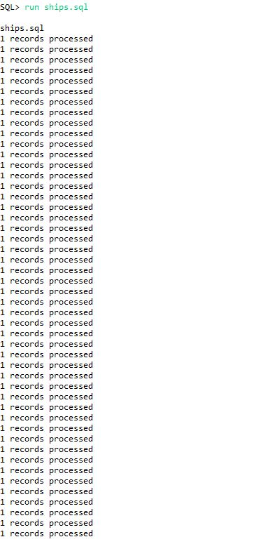

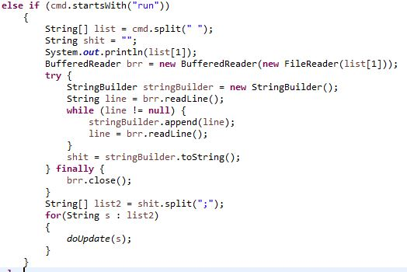

An aggie does not lie, cheat, steal, or tolerate those who do.